Proportional Stage (P)
- Sine Wave Test
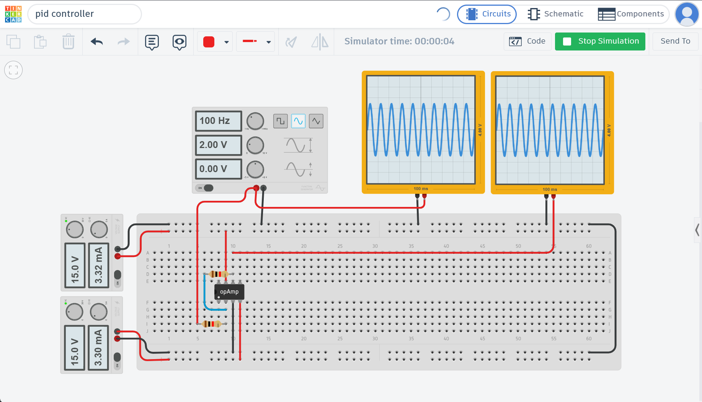

- Square Wave Test
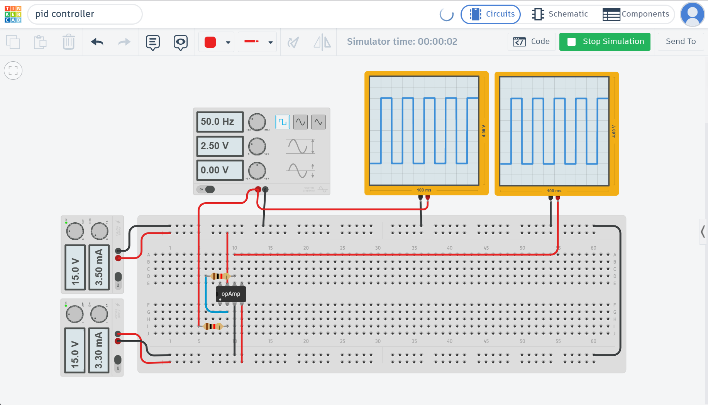

- Sawtooth/Triangle Wave Test
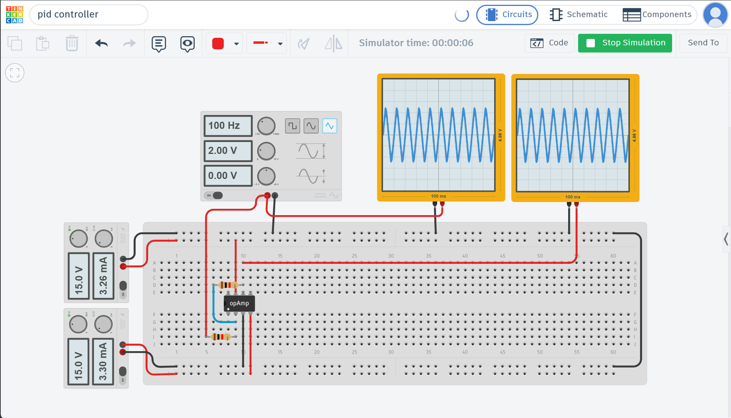

Integral Stage (I)
- Sine Wave Test
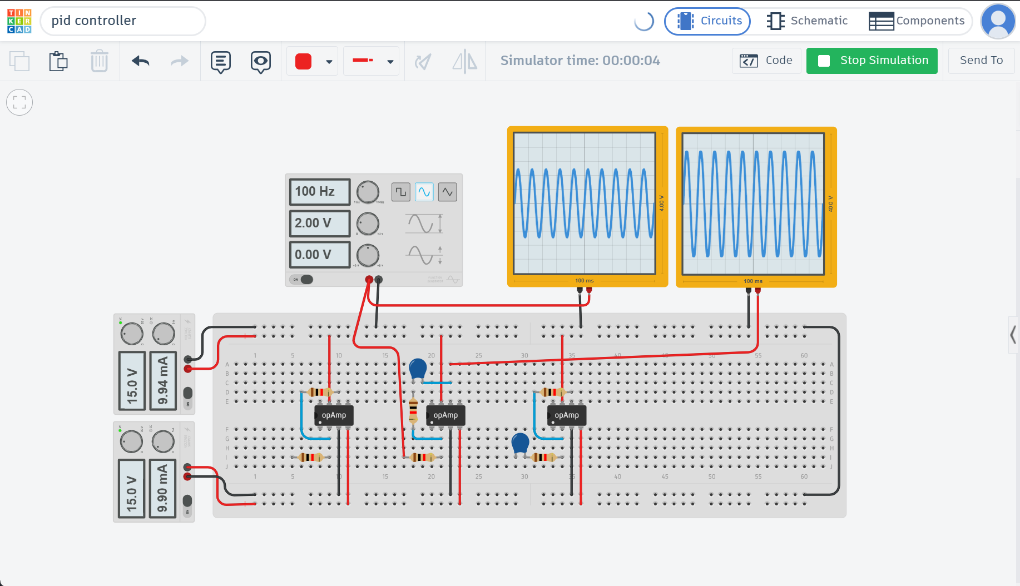

- Square Wave Test
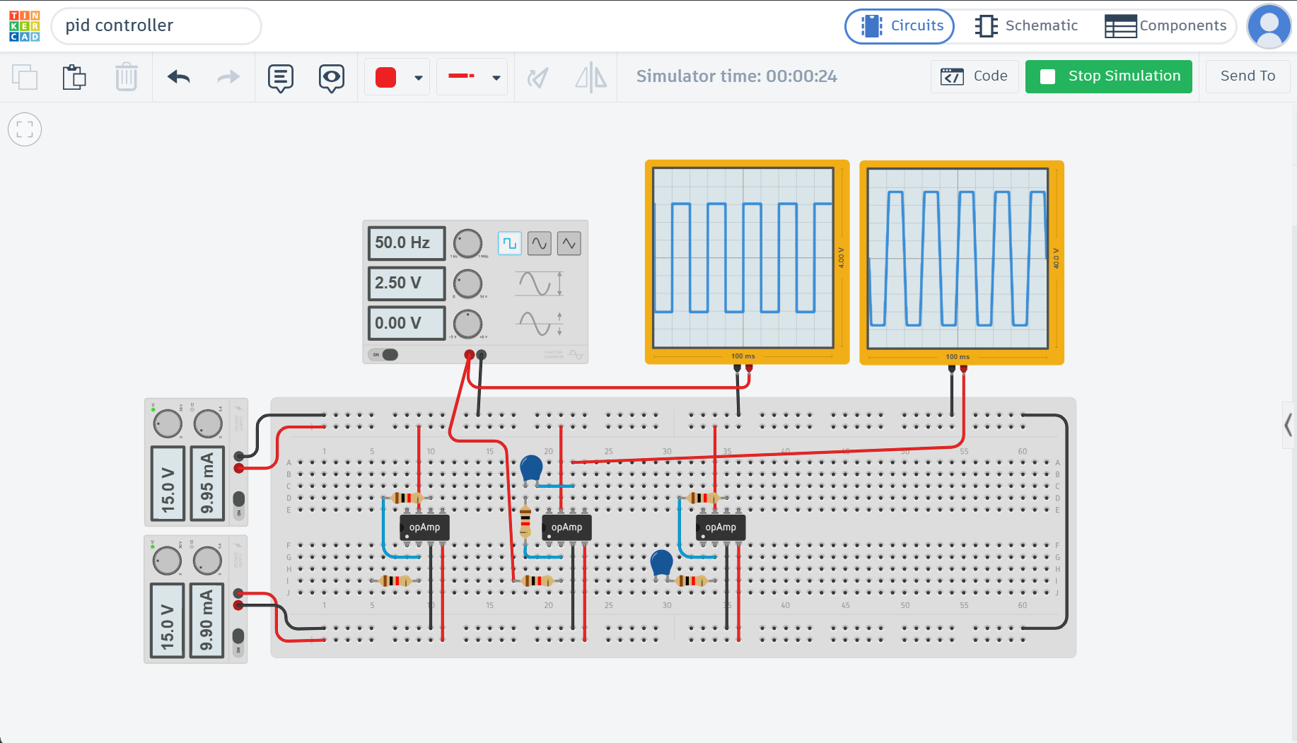

- Sawtooth/Triangle Wave Test
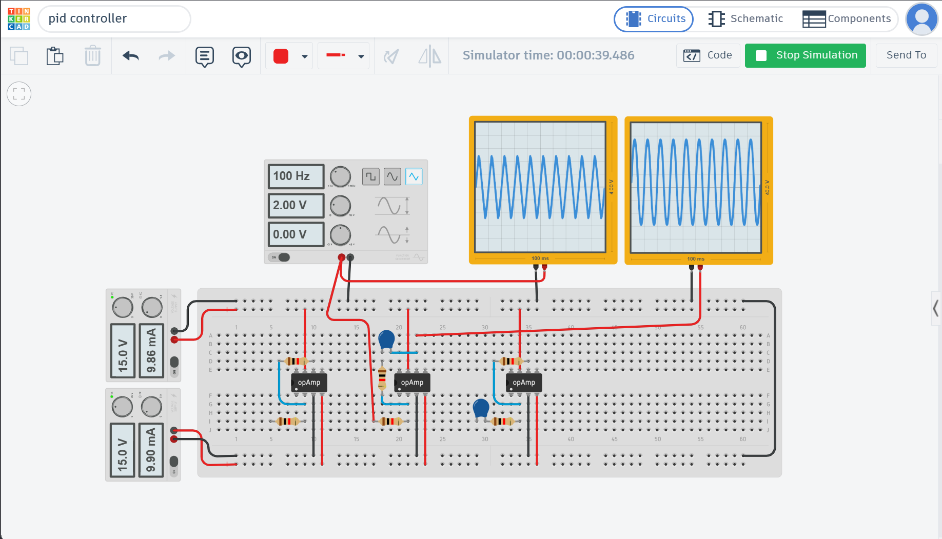

Derivative Stage (D)
- Sine Wave Test
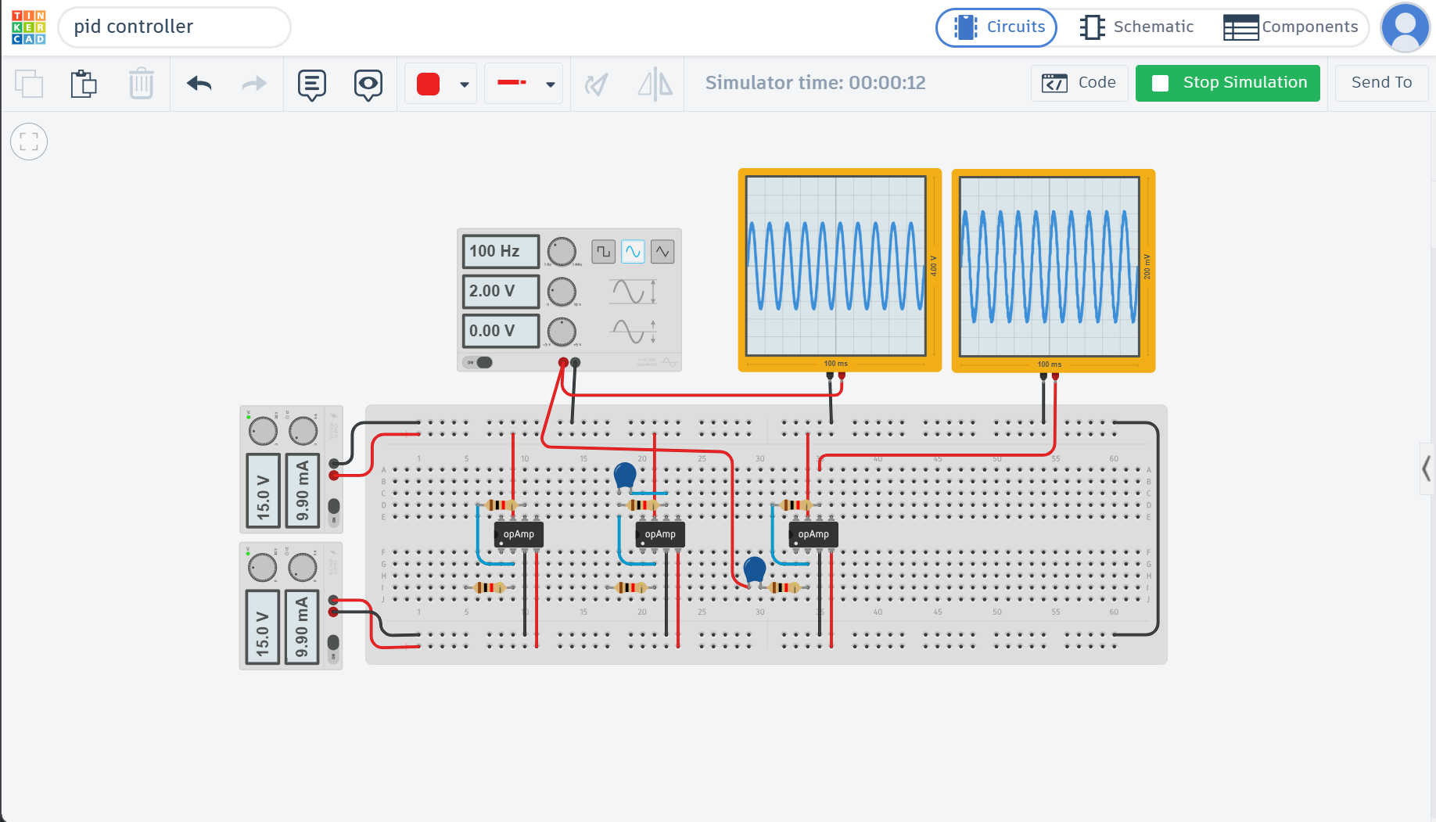

- Square Wave Test
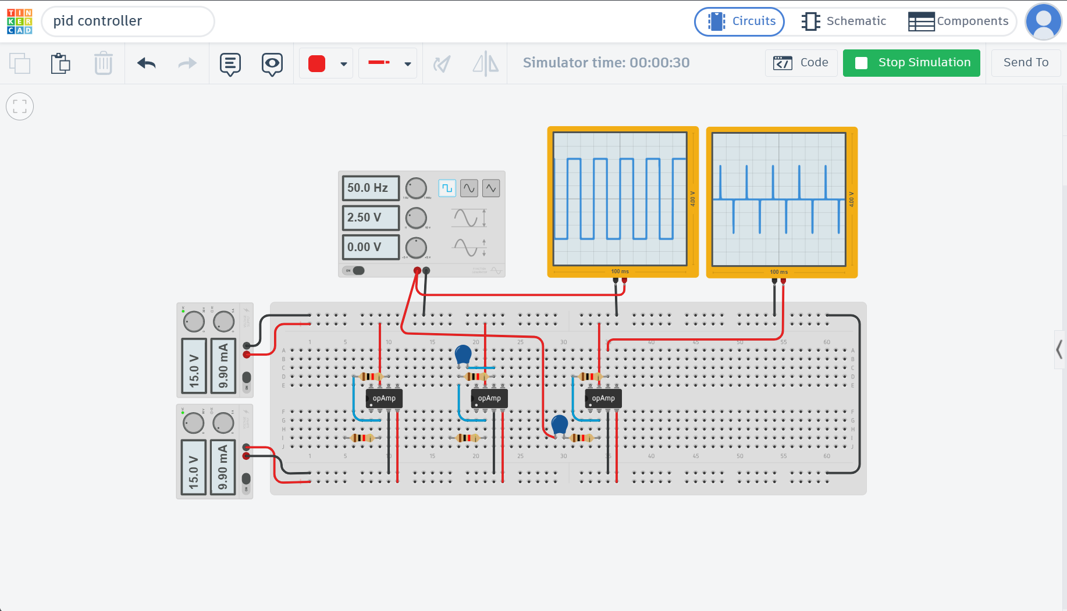

- Sawtooth/Triangle Wave Test
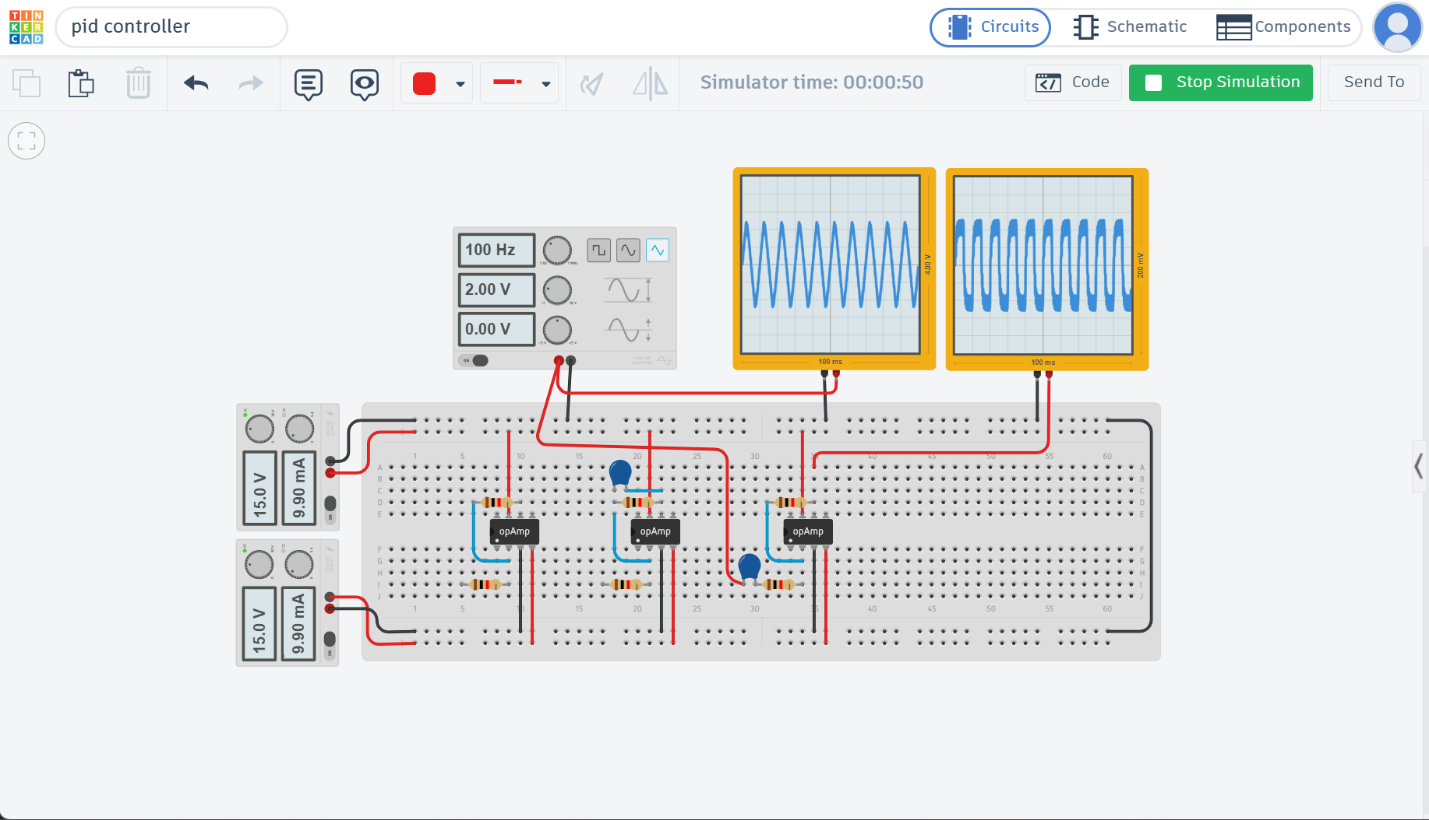

PID (combined output)
- Sine Wave Test
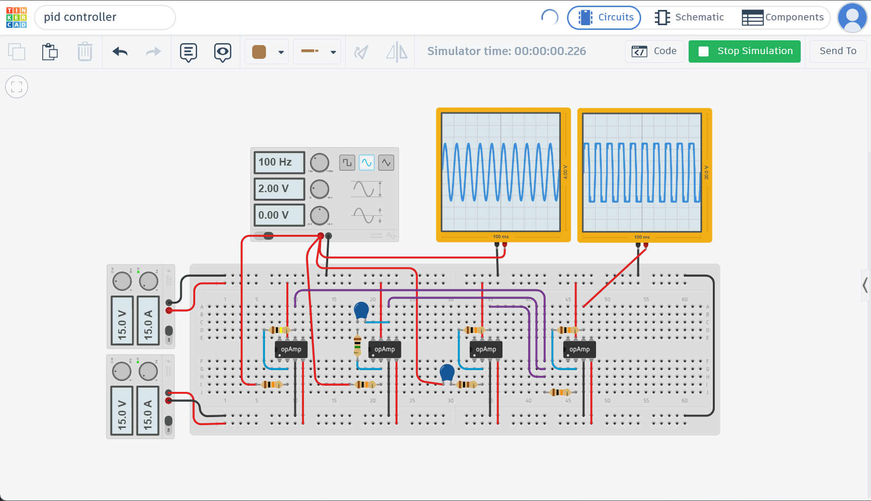

- Square Wave Test
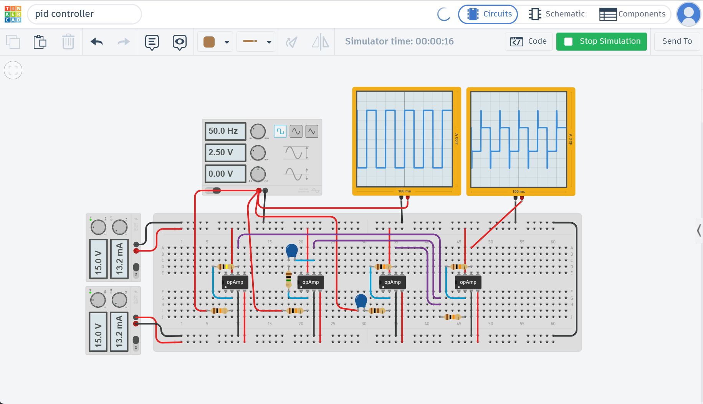

- Sawtooth/Triangle Wave Test
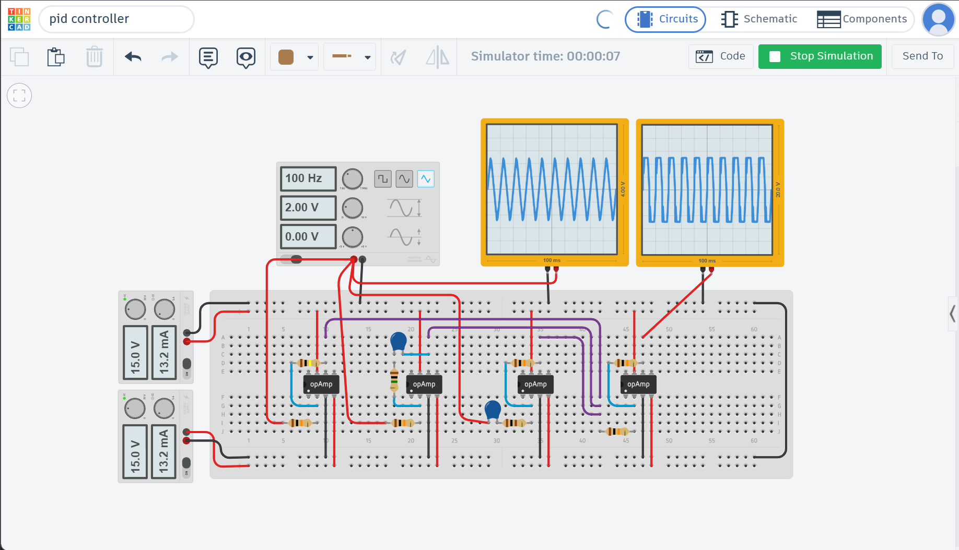

Tinkercad link:
https://www.tinkercad.com/things/8S8z7HPzGC4/editel?sharecode=s0UrxF2TndEjycqA7XCsGM2uMu6uTKTMAVBif3xa5zM

